3. Project Design Phase

3.1 System Architecture

The system follows a layered architecture. Users interact with the web interface, requests are processed by the Python application layer, persistent records are stored in MySQL, and AI services operate as an additional service layer.

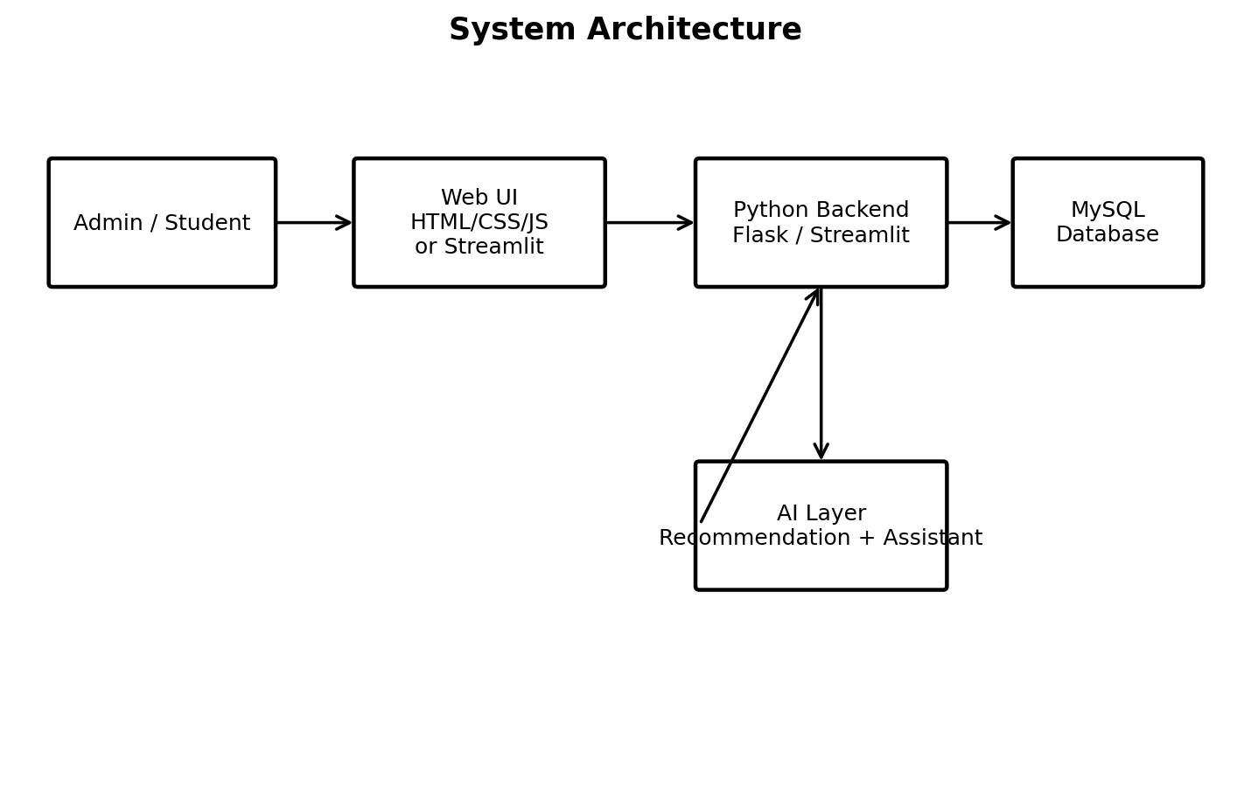
3.2 Use Case Diagram

The main actors are Admin and Student. The Admin manages students, courses and reports. The Student registers/logs in, browses courses, enrolls or withdraws, receives recommendations and asks the AI assistant questions.

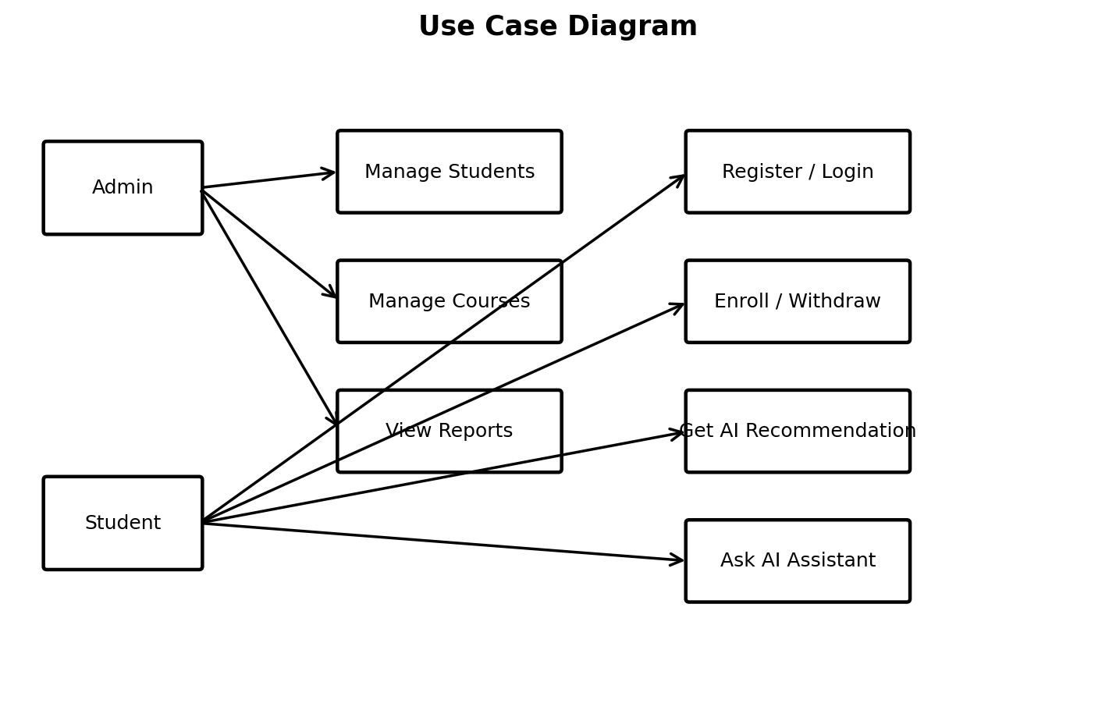
3.3 Data Flow Diagram — Level 0

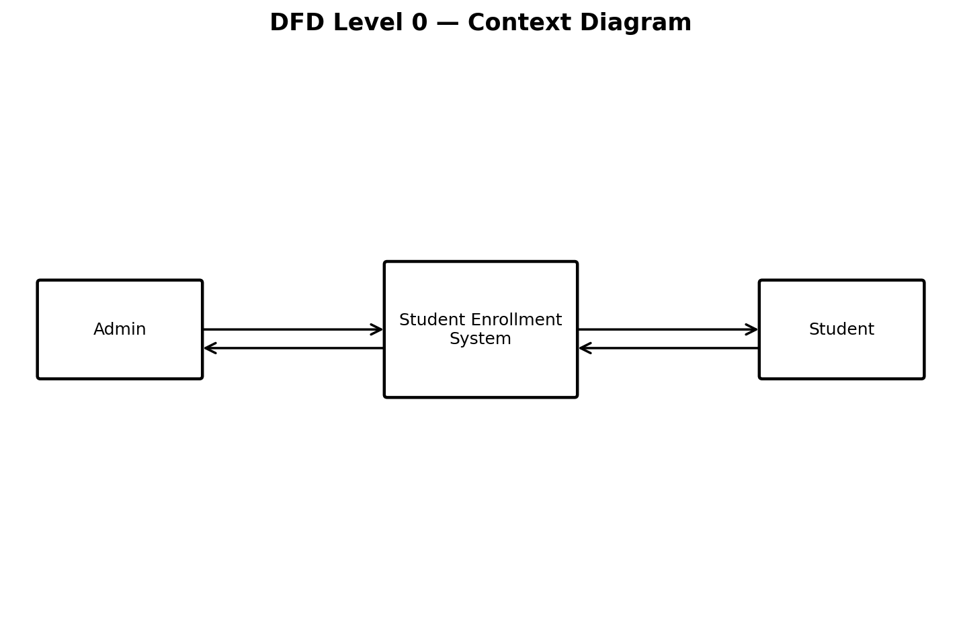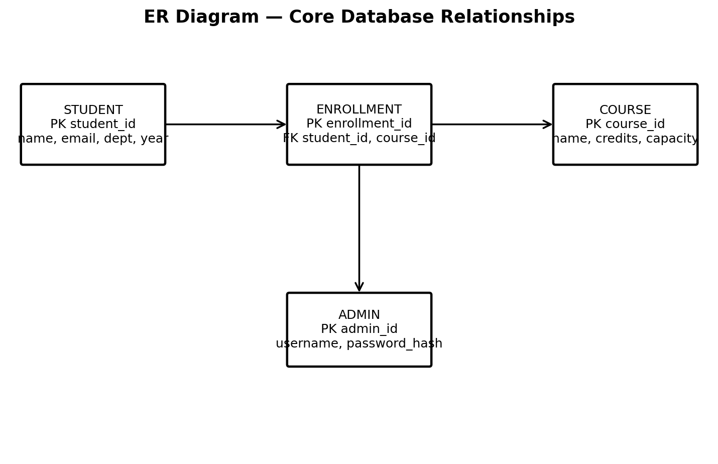.

3.6 Database Design
Table | Key Fields | Purpose
students | student_id PK, name, email, department, year, phone | Stores student information.
courses | course_id PK, course_name, description, credits, capacity, category, prerequisite | Stores course information.
enrollments | enrollment_id PK, student_id FK, course_id FK, enrollment_date, status | Connects students and courses.
admins | admin_id PK, username, password_hash | Stores administrator credentials.

3.7 Module Design
